**project management plan**

**for the**

**Therapy Booking System**

**TBS**

**30-10-2021**



Team Names:

Team Member 1: Ashraf Adel - 196280

Team Member 2: Jacinta Samir - 206562

Team Member 3: Yasmine Sameh - 206197

Team Member 4: Rahma Abdulla -196192

**Therapy Booking System, 21CSCI08ITable of Contents**

**Section Page**

**SECTION 1. OVERVIEW** **3**

1.1 Project Summary 3

1.1.1 Purpose, Scope, and Objectives 3

1.1.1.1 Purpose 3

1.1.1.2 Scope 3

1.1.1.3 Objectives 4

1.1.2 Assumptions and Constraints 4

1.1.2.1 Assumptions 4

1.1.2.2 Constraints 4

1.1.3 Project Deliverables 5

**SECTION 2. PROJECT ORGANIZATION** **6**

2.1 Project Roles and Responsibilities 6

2.1.1 Team Organizational Structure 6

2.1.2 Roles and Responsibilities 6

2.1.2.1 Analysis Manager 6

2.1.2.2 Design Manager 7

2.1.2.1 Implementation Manager 7

2.1.2.1 Testing Manager 7

**SECTION 3. TECHNICAL PROCESS** **7**

3.1 Methods, Tools and Techniques 8

3.1.1 Methods 8

3.1.2 Tools and Techniques 8

3.1.2.1 Tools 8

3.1.2.1 Techniques 8

**SECTION 4. TECHNICAL PROCESS** **9**

4.1 Project Infrastructure 9

# SECTION 1. OVERVIEW

## 1.1 Project Summary

### 1.1.1 Purpose, Scope, and Objectives

#### 1.1.1.1 Purpose

This website will allow people who are having mental problems to seek out professional help quickly and easily by booking with a suitable therapist either online or face-to-face. It will also inform people in a life-critical state about the possibility of contacting Egypt Suicide Hotline for quick consultation.

#### 1.1.1.2 Scope

Patient (user):

When the patient opens the website for the first time, a quiz will be displayed which will help with the patient problem identification. However, after taking the test if it isn’t a critical case (suicidal case) a signup form will appear. After filling the form a number of recommended therapists (specialized in the patient’s disorder) will be revealed according to the identified disorder, the patient has to book an appointment with one of the displayed therapists, choose the way of communication (online, face to face), and decide the payment method; if online, then he/she have to fill the credit card requirements, a confirmation mail will be sent each time a transaction take place. There will be a chat box as a way of direct communication between the patient and the chosen therapist; if the test results showed a suicidal case, then the website will display “Egypt Suicide Hotline: 7621602”.

Therapist:

The therapist has to fill in their profile with Specialization, experience, degrees, time schedules, and way of meeting (if the session will be online or offline). After the patient answered the questions of the mandatory quiz, the specific therapists that specialized in similar cases could check the results that determined its type of disorder. If the therapist accepts the request, then the therapist would be able to make contact with him through the chat to follow up the patient’s case.

Admin:

The admin could accept or decline the request of the patient according to the therapist's schedule that he/she is responsible for. Also, the admin could delete a therapist if he/she decides that he/she would not be able to provide service on the website anymore. Finally, the admin could remove a patient/therapist if they infringe the rules of the website in any way possible (e.g. using vulgarity expressions while talking in the chat).

#### 

#### 1.1.1.3 Objectives

1. revenue for the company.
2. Increased knowledge in using web development software.
3. public recognition of the company from healthcare institutions.
4. Insurance for the company’s staff over any mental issues that they might have (where our product provides therapy sessions without costing them).
5. Raising awareness about mental health issues which in turn helps us gain more clients.

### 1.1.2 Assumptions and Constraints

#### 1.1.2.1 Assumptions

1. Management assumptions:
   * The creation of the website will be distributed among 4 people.
   * The team is expected to make the website supported on pc, and mobile screen devices, tablet screens could be left out in the case of limited resources.
   * All employees are expected to be present on all working days (however, there may be days when someone is sick/unable to come into work/etc.)
2. Technical assumptions:
   * The user (patient) is expected to be older than 12 years old.
   * The user is expected to take the quiz first, which its results will tailor the recommended therapists on the result page.
   * If the user doesn’t take the quiz and searches for a specific term (therapist name, disorder name, etc.), then it is assumed that they have knowledge of their disorder.

#### 1.1.2.2 Constraints

1. Management constraints:
   * The total budget that the company has allocated for this project is 30,000 EGP.
   * The company has allocated a maximum of 10 pcs to use in the process of building this website.
   * Employees will work on weekdays from 9:00AM to 4:00PM
   * The project should be finished before 22-11-2021
2. Technical constraints:
   * The website should be able to handle about 10000 user requests at a certain time frame.
   * The website should go down for a maximum of 1 time per month.
   * The therapist should reply to a patient’s request in a maximum of 3 days.
   * The website should be available in both English and Arabic

### 

### 1.1.3 Project Deliverables

| Phase | Outcomes |
| --- | --- |
| Analysis | * System Requirements Specification (SRS) document - Delivery date: 5-11-2021 * Business Requirements Document (BRD) - Delivery date: 5-11-2021 * Use-case diagrams - Delivery date: 6-11-2021 |
| Design | * wireframe of the website - Delivery date: 8-11-2021 * Sequence diagram - Delivery date: 10-11-2021 * class diagrams - Delivery date: 12-11-2021 |
| Implementation | * Source code - Delivery date: 16-11-2021 * Database - Delivery date: 18-11-2021 * Working prototype of the website - Delivery date: 18-11-2021 * Code documentation - Delivery date: 19-11-2021 |
| Testing | * Bug report documents - Delivery date: 21-11-2021 * Test scenarios document - Delivery date: 23-11-2021 * Test summary report - Delivery date: 25-11-2021 |

# SECTION 2. PROJECT ORGANIZATION

## 2.1 Project Roles and Responsibilities

### 2.1.1 Team Organizational Structure

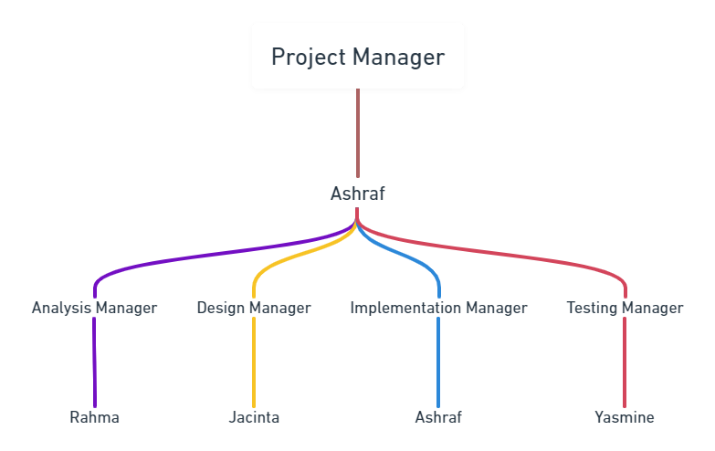

### 2.1.2 Roles and Responsibilities

#### 2.1.2.1 Analysis Manager

* Ensure the continuity of service by providing the planning, leadership, and project coordination necessary to implement new projects and optimize old ones.
* Track, resolve, and document root causes of user technical problems.
* Provide demos for product management.
* Develop and deliver operational reports and summaries of problems or technical difficulties.
* Prepare and present financial and economic models for the board of directors, managers, and investors.
* Assess infrastructure and platforms to judge feasibility and usefulness of available tools and resources.
* Comply with department methodologies and software development methodologies.
* Documenting interactions from the business owners.
* Identify and communicate project and design risks to the project manager.

#### 2.1.2.2 Design Manager

* Outlining how the design team will implement the required deliverables.
* Conducting regular meetings with the design team to ensure that the design process is on schedule, giving needed input and advice as well as building motivation.
* Coming up with effective design solutions and making the necessary decisions.
* Presenting to upper management the design strategy.
* Overseeing that all design documents are produced on time and to a high standard.

#### 2.1.2.1 Implementation Manager

* Draft an implementation strategy to ensure the new system is right for the company's goals.
* Introduce the technologies that will help in the development of the project.
* Delegate tasks properly; Senior programmers should take on difficult parts of the project that require a high level of problem solving skill, while junior programmers can take on easier parts of the project.
* Monitor the system throughout different stages to ensure the functions that were required are met, and later on suggests to the project manager/project board potential improvements for future versions of the project.

#### 2.1.2.1 Testing Manager

* The primary responsibility is to define the test strategy and coordinate the activities from the beginning till the end.
* Make a detailed plan to define the matrix which checks the progress of the task which is called test plan.
* Controlling the team budget, deadline and activities within the team.
* Make the test summary reports towards the end of any project
* Responsible for design test environment and also the configuration management, he will keep track of all the versions of the software’s and tools used for the testing.

#### 

# **SECTION** 3**. TECHNICAL PROCESS**

## 3.1 Methods, Tools and Techniques

### 3.1.1 Methods

| Type of Methodology | Methodology Used | Justification |
| --- | --- | --- |
| Software Project Management (SPM) | Stepwise Approach | Stepwise is the most suited one to use in planning this project, as it is known for its practicality; the steps of this approach are clear and concise. Also, it is scalable; it can work on big projects as well as small ones, and the TBS is currently a small project, so it will be practical for it. Finally, this approach is chosen due to elimination of other approaches; The PMBOK approach isn’t a concise methodology, but rather a set of guidelines which should be followed, but for a well understood project like the TBS, clear instructions of what to do next should be given instead of guidelines. The PRINCE2 methodology also is not recommended, as it requires a lot of documents which will increase the project’s timeline, and the TBS project has a very tight deadline schedule. |
| Software Development (SDM) | Waterfall Methodology | Since the TBS website will be initially small, and its details are fleshed out from the start, it is not likely that there will be changes as the project proceeds which also means a need for iteration is not likely. This makes waterfall methodology a good candidate for this project. |

### 3.1.2 Tools and Techniques

#### 3.1.2.1 Tools

For logo design: Krita and graphicsprings

For team communication: Zoom

For discussing project details: Google docs

For visualizing management details (e.g. Team Organizational Structure): Whimsical

#### 3.1.2.1 Techniques

The project was done as a website instead of an executable program, as it is more accessible to the user if they can enter from different devices (PC, mobile, etc) to get the same feature. Also, the project functionalities are simple enough to be implemented on a website.

Client-side scripting languages: HTML5, CSS, Javascript

Server-side programming languages: PHP

For logo design: Krita

For team communication: Zoom

For discussing project details: Google docs

# SECTION 4. TECHNICAL PROCESS

## 4.1 Project Infrastructure

hardware,operating system, network m3yan

* Hardware: The website doesn’t have any complex functionalities or exorbitant design, so it can run with low-end devices (e.g on pc: 2gb RAM, dual core processor, etc).
* Operating Systems: compatible with all the systems (Windows, MAC, Linux), as this is a website, not an application.
* Intended network that the website will run on: Wide Area Network (WAN).